**SCREENSHOTS OF PROJECT**

**CHAPTER 6**

**SCREENSHOTS OF PROJECTS**

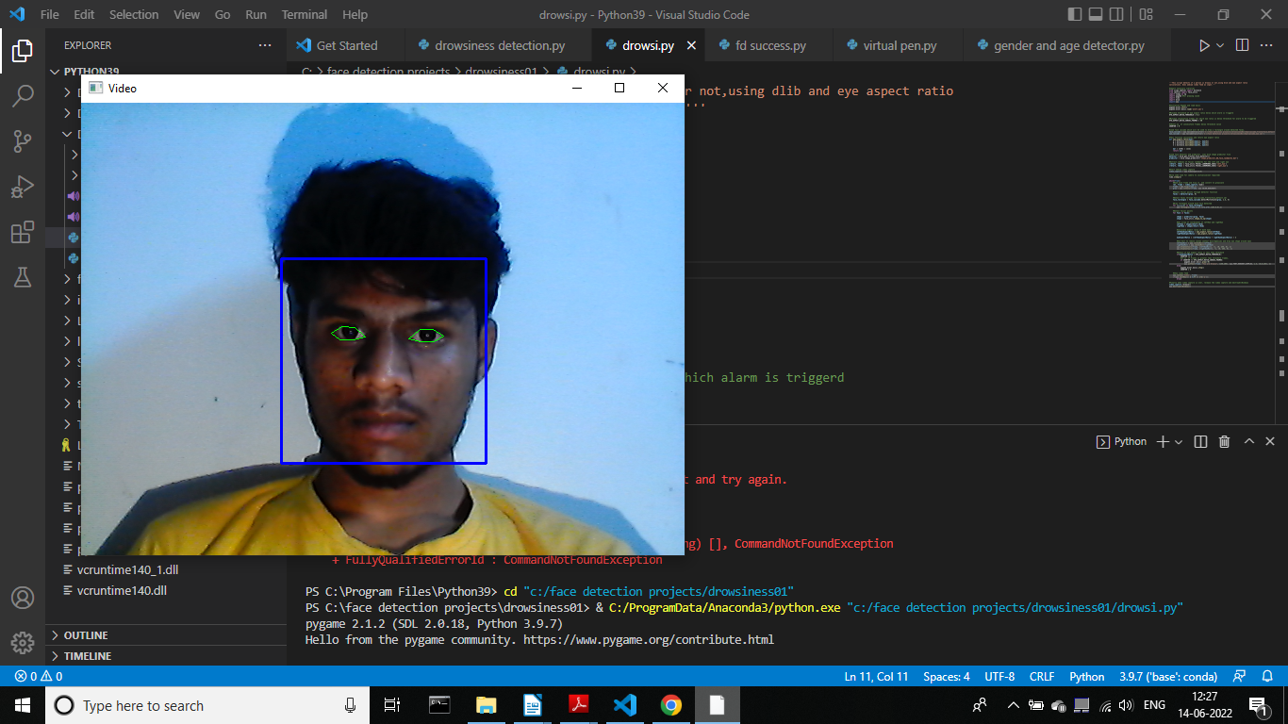

**Figure 4.5 Non drowsy person**

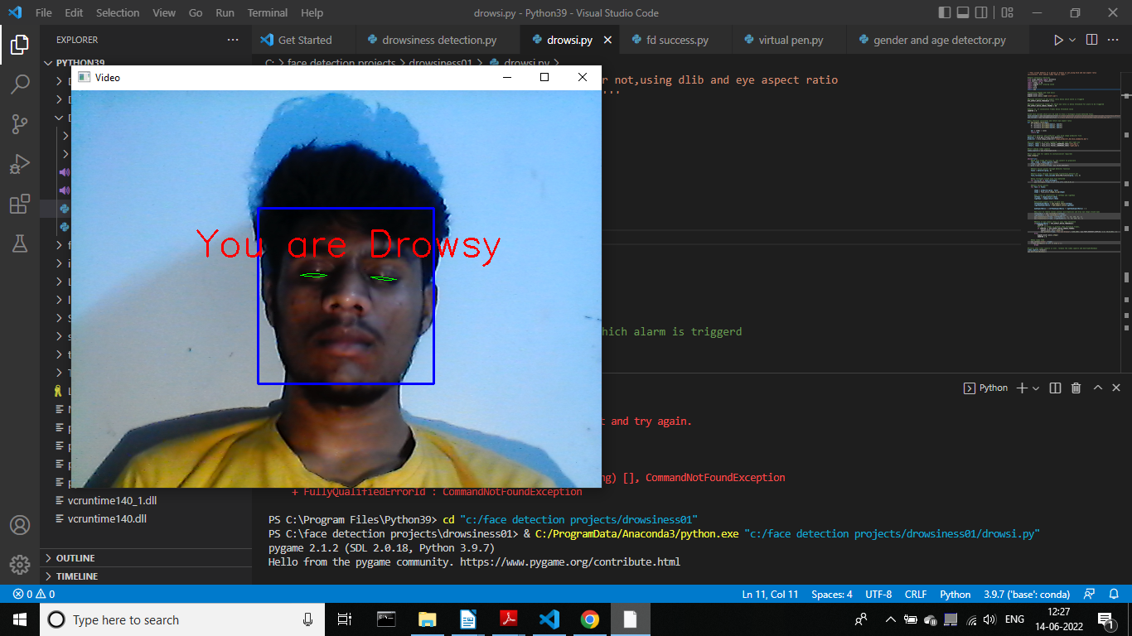

**Figure 4.6 Drowsy person**

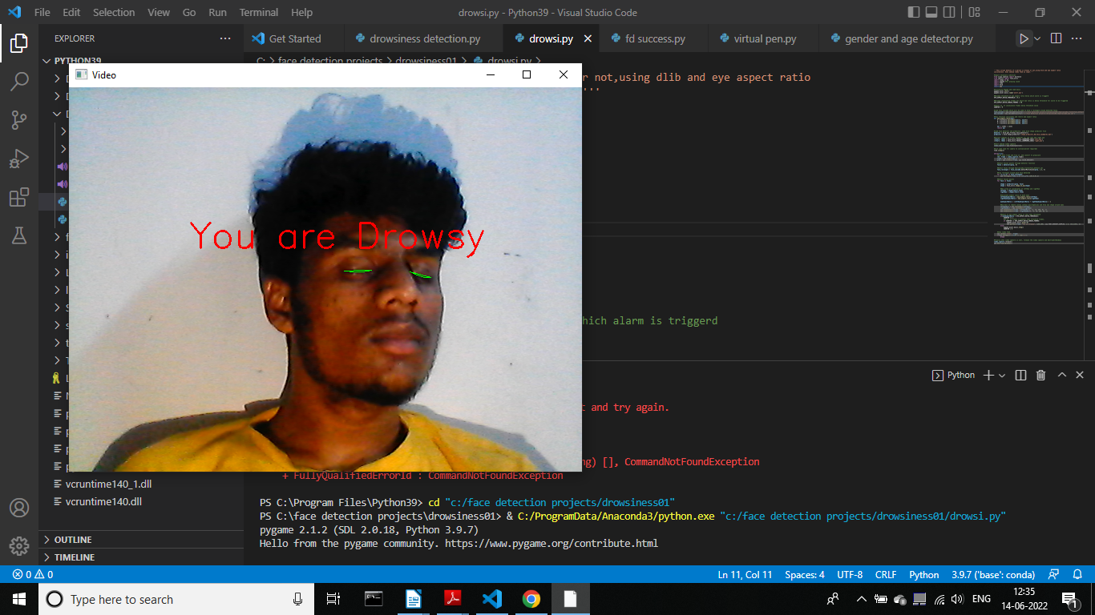

**Figure 4.7 Little Sleeping**

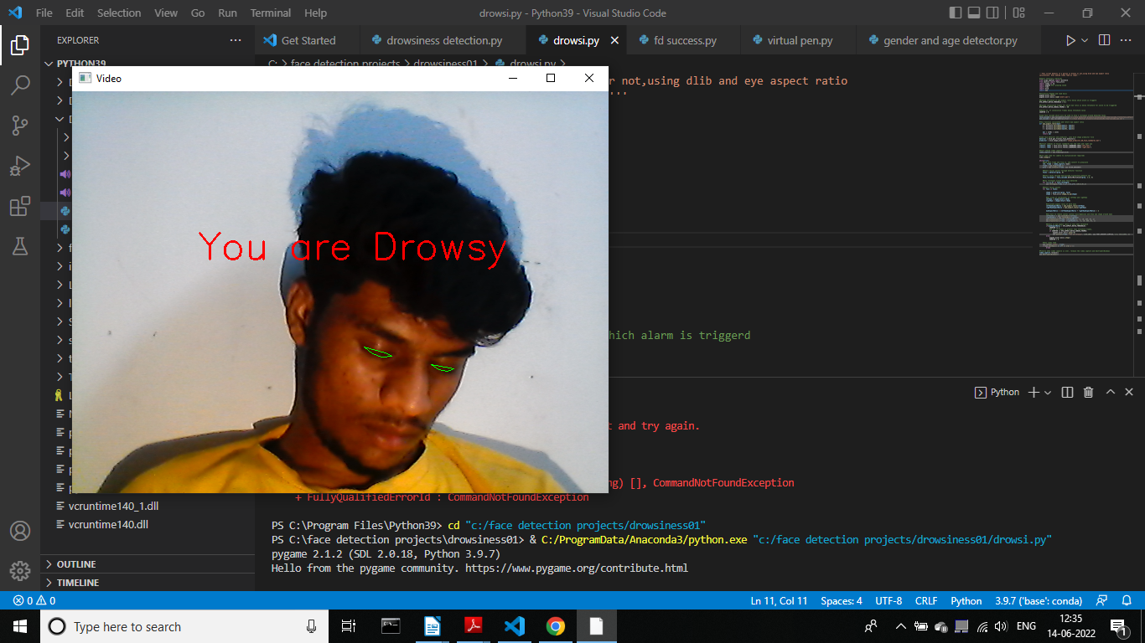**Figure 4.8 Sleeping Overload**